Now lets go and test it in our game and see how this is working
We don't have any so we will use the emulator in our Unity.
So go to window menu and then a submenu will be opened then go to general and then again another submenu will be opened then go to Device Simulator.
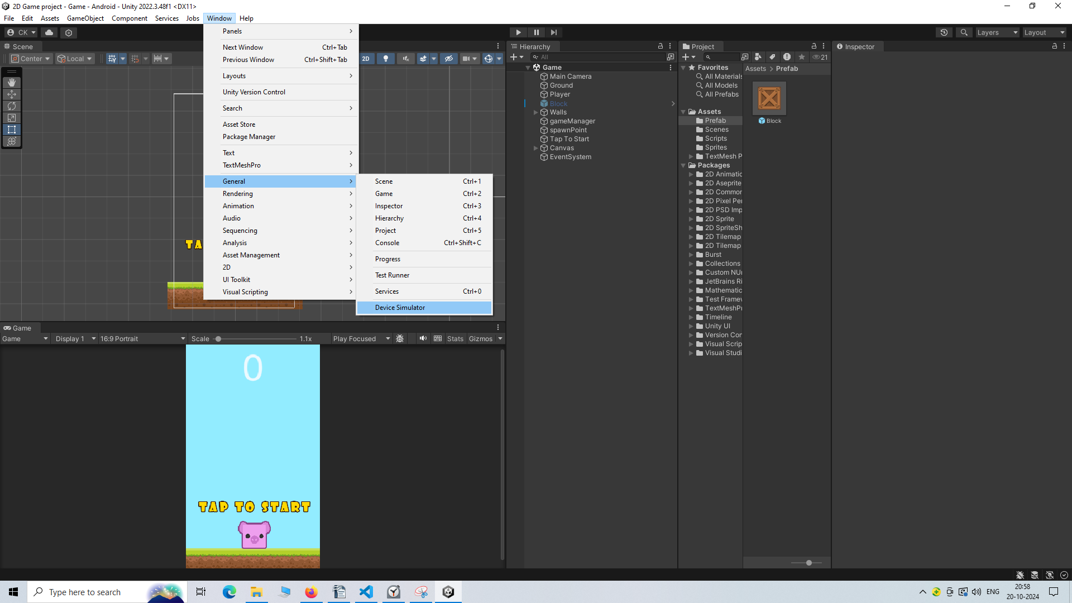
Now our android simulator will be opened like below
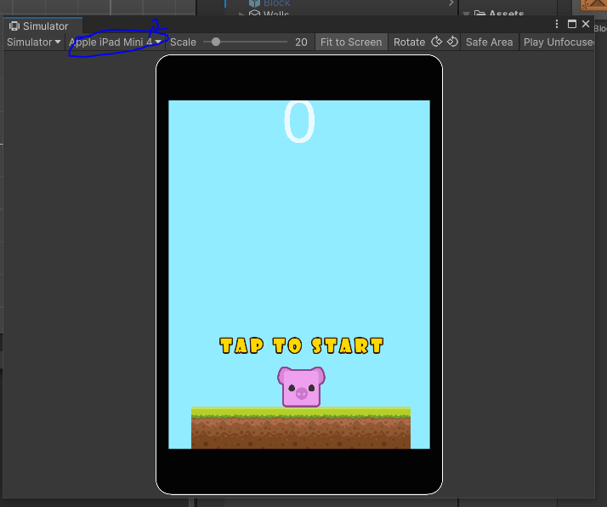
In our simulator we can see the Apple Ipad Mini 4 phone we will change the device simulated.
So we will click on the marked area a submenu will be opened
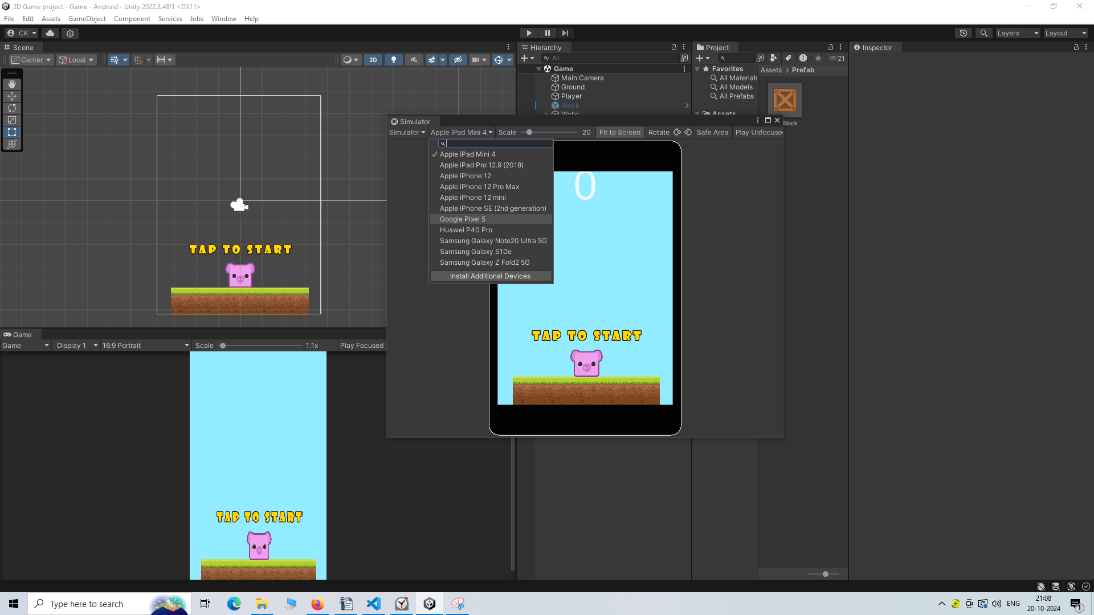
and in that option choose Galaxy5
Now our simulator will look like below
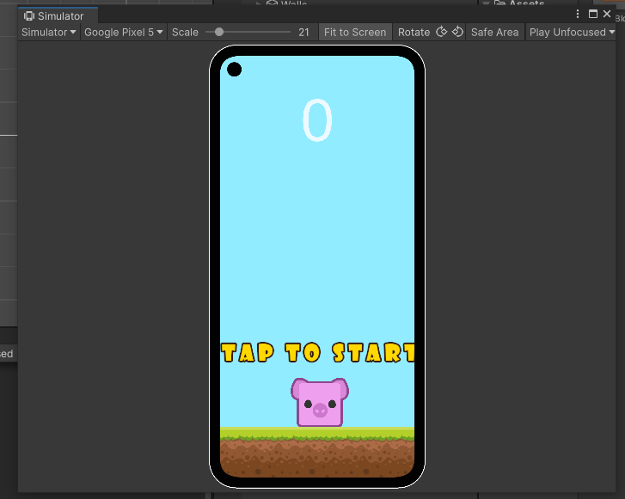
Now we will click on play button(as previously discussed) in Unity and see in simulator how our this will work in a real mobile device
Now since the tap to start image is not showing properly on the screen. So in our scene panel we resize so that it will fit in our screen.
___________________________________________________________________
Note:-
when the simulator window is active then in the game panel you will see its scene change and it is trying to match it to how much is shown on the simulator screen (who knows) otherwise the game panel will only show you normal screen.
___________________________________________________________________
You can also make your Tap to text IOA to UI element just like our scoretext then it will look even
So we will convert "Tap to text" image to UI text by right click on canvas a submenu will be opened
and then go to UI and agian a submenu will be open beside it now go to Image as shown below.
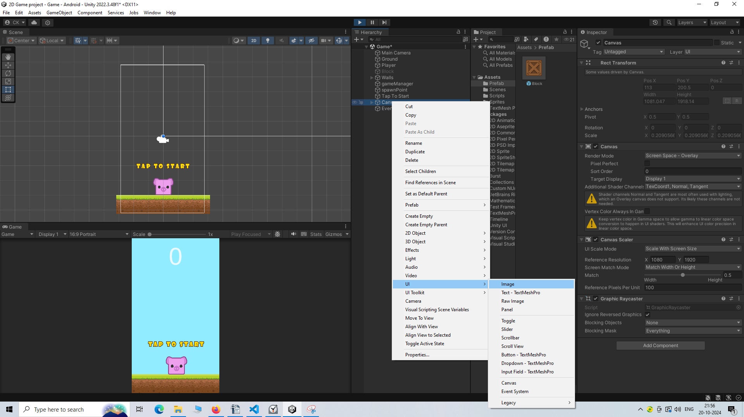
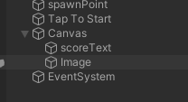
Now you can see the image IOA inside parent canvas IOA.
Now we will rename it to "Tap image"
Now we will go to its inspector panel
and then go to Image subpanel and then in source image choose the image by clicking on the marked below
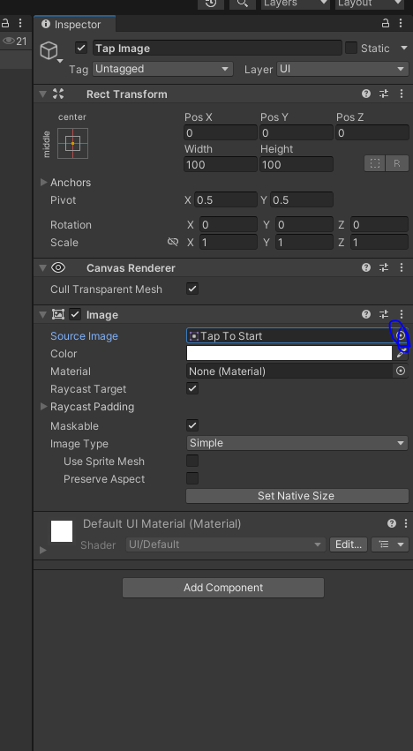
Now a small window with the title Select Sprites as shown below
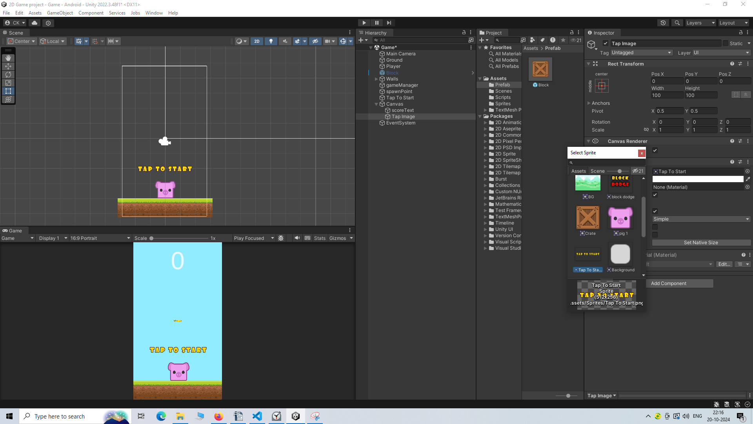
or you can drag and drop the image in the sprite folder into source image field of image panel

Before adding image the Tap image IOA will look like marked below
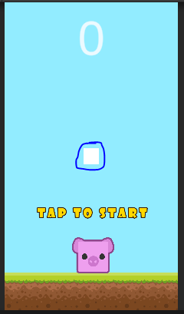
Now after adding, it will look like below
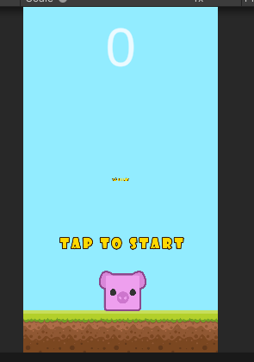
but it is not of the same size from the image it is made from
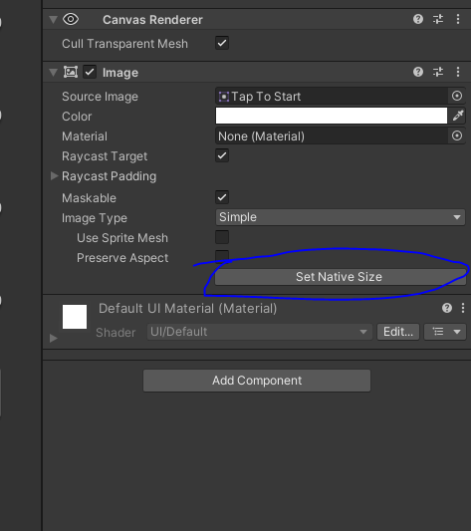
So to make our UI element equal to its image size
click on the set Native Size as marked above
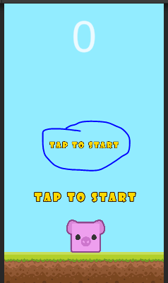
Now from the marked above you can see it is slightly come closer to its image size.
If you are not satisfied with the size then you can resize it by a scale tool.
I think in above we clone an image and convert the clone into a UI element.
Disable the Tap To Text IOA
So by this way we use UI element instead of random game object just to create Tap Text
So that it get automtically get scaled according to our different sizes of the screen.
I think the image UI Element which come under canvas unlike TextMeshProUGUI get scaled by default.
And all the option shown in UI submeny will only work when they will be under canvas parent
which may be added as parent when you add UI element for the first time in heirarchy panel.
Now we will remove Tap to Text IOA from the GameManager Script and instead out newly formed Image UI of Tap to Start UI
The Image UI also come under GameObject class
_____________________________________________________________________
Note:-
To remove value from a field in the script panel press backspace
_____________________________________________________________________
So to make the Game cooler
You can create a title text to make the game look cool
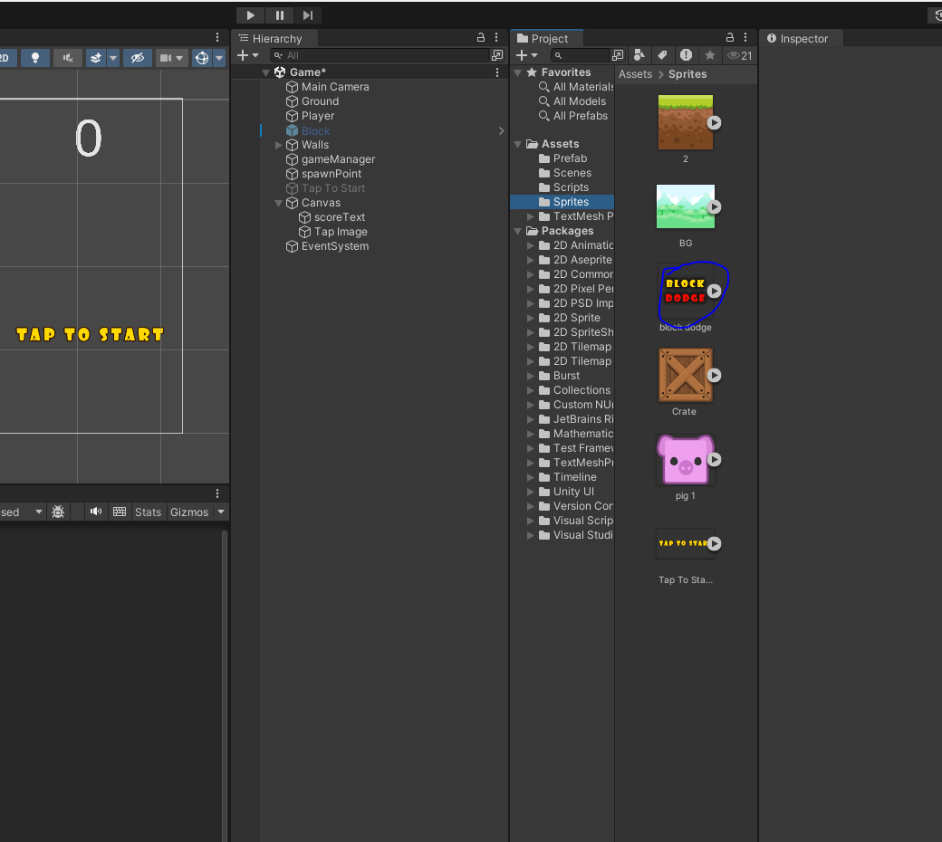
In above marked you can see the title text the teacher has created
You can create your own if you want to and use it.
Now for that image we again create UI element like we did of tap to text image and then automatically it will be formed under the canvas name it as title
and set its image source as marked above or the image you chosen for the title
_______________________________________________________________
Note:-
All theUI elemet will go under cancas and it dies not matter where you made your UI
_______________________________________________________________
Nw set it to naive as preiously discussed
You can go ahead and make it bigger if you want to Suit your game
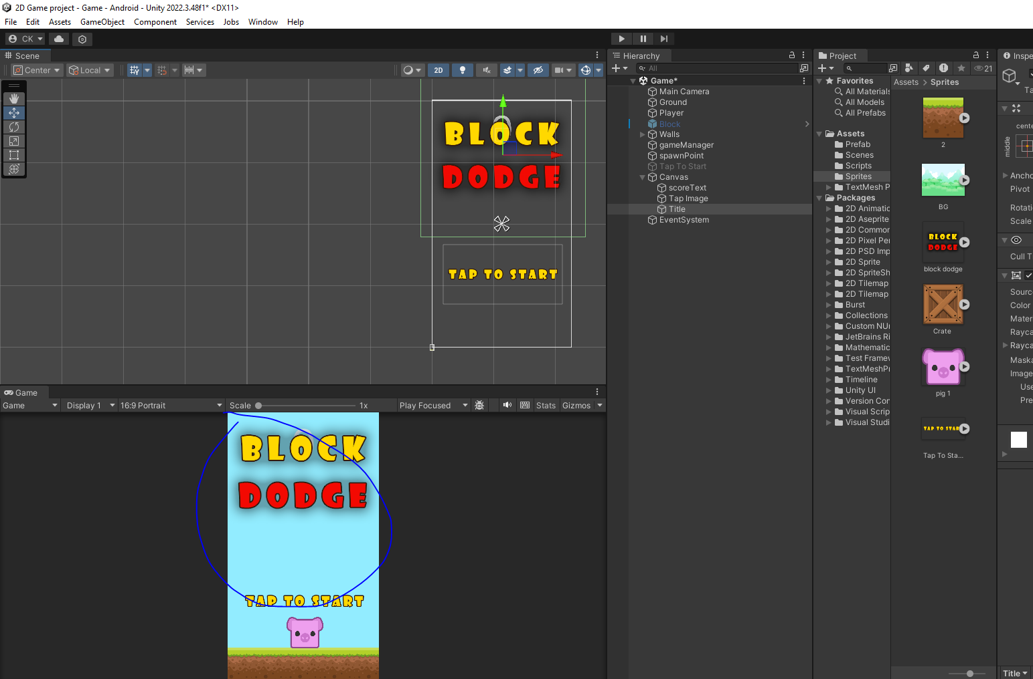
Now our screen will look like marked above
Now we are going to make the Title UI element IOA the child of Tap to text IOA by dragging and dropping Title IOA on the Tap to text IOA
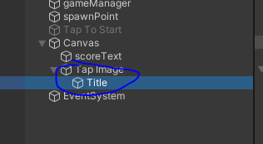
Now it will look like above
Now when the Tap image get disbaled the Title IOA will also get disables since the title IOA is child of Tap Image IOA
Now we will test our game in our simulator

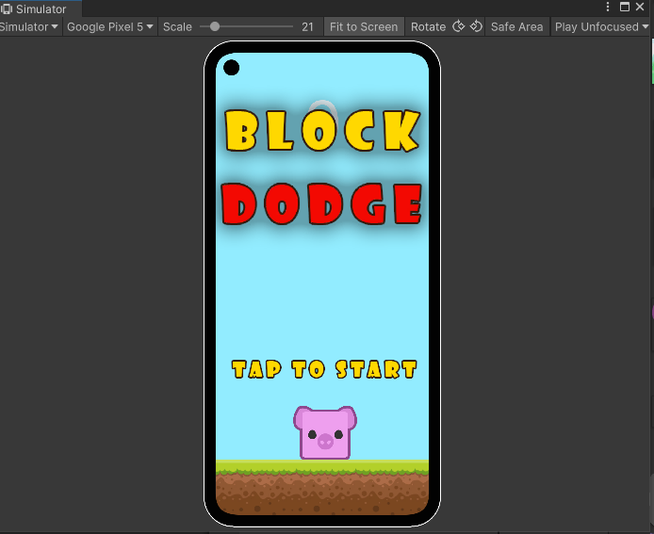
Now it is working well and the title get removed when you click on the screen first time and the game starts and score get updated when a bloxk id created and we dodge it
and when the block touch the player again the title is shown again they will be removes when the game will be started

